**Step-by-Step Guide for Employee Task Execution**

### 🔧 Task 1: Install an On-Premises Data Gateway

**Step 1:** Download the gateway installer from the official Microsoft site. <https://learn.microsoft.com/en-us/data-integration/gateway/service-gateway-install>

**Step 2:** Choose **Standard Mode** and install.

**Step 3:** Sign in using your Power BI (work) account.

**Step 4:** Choose **“Register a new gateway on this computer”**.

**Step 5:** Assign a gateway name (e.g., HR_Gateway) and set a recovery key.

**Step 6:** After configuration, check if the gateway status is **“Online and Ready”**.

*Refer screenshot below:* > Gateway Status

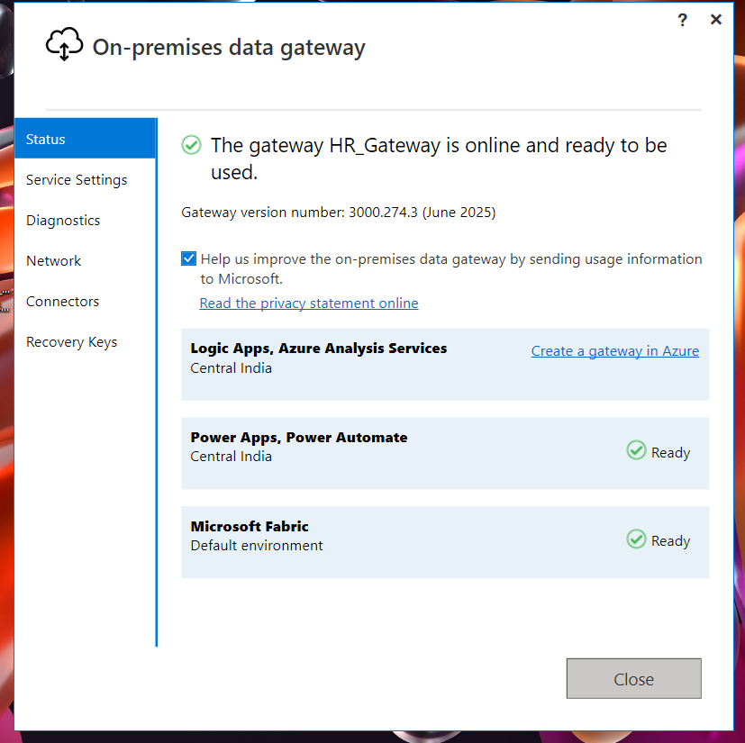

### 🔄 Task 2: Update Rows in Excel Before Refresh

**Step 1:** Open the Excel file (Employee Data Sheet.xlsx).

**Step 2:** Enter or update new employee data as required (like billed hours, manager, dates, etc.).

**Step 3:** Save the file in the same location used in Power BI (C:\Users\Asus\Downloads).

**Step 4:** In Power BI Desktop, click **Refresh** to verify that new data loads correctly.

*Refer screenshot of Power BI report layout:* > Power BI Report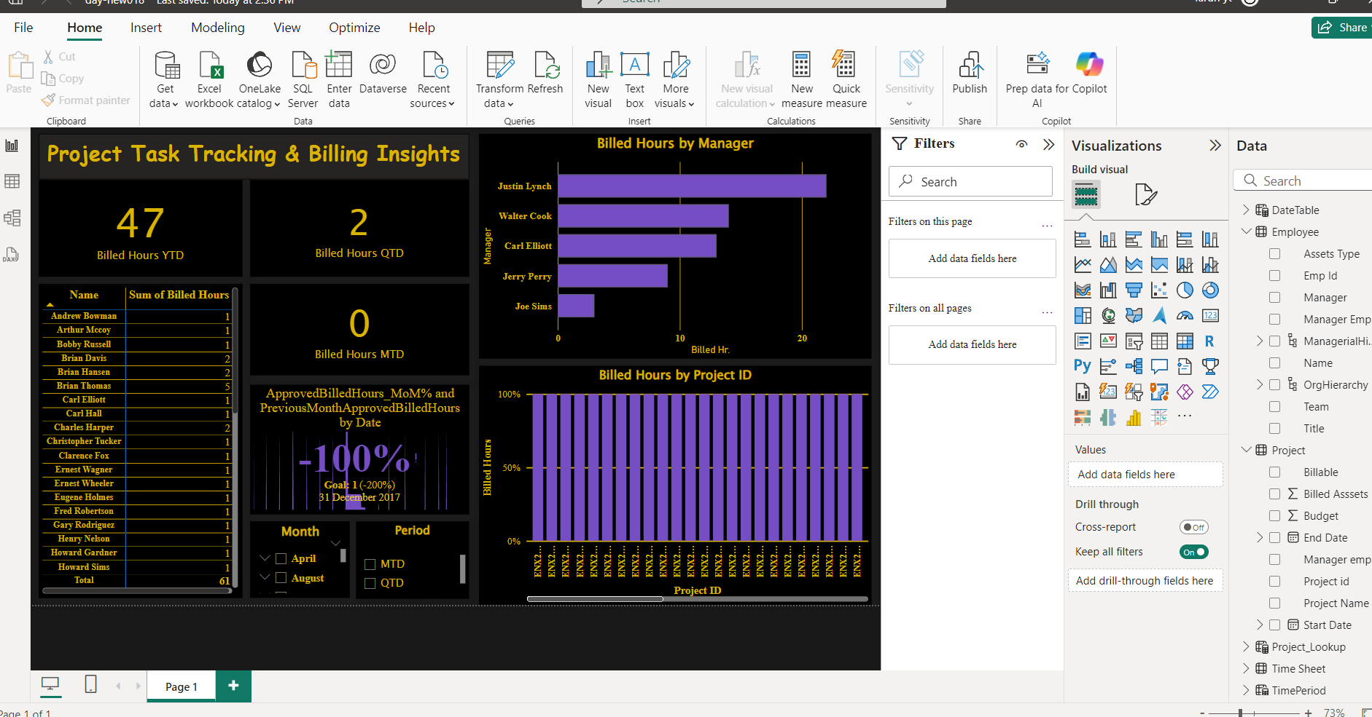

### 🚀 Task 3: Schedule Report Refresh Using the Gateway

#### 3.1 Publish the Report to Power BI Service

**Step 1:** Click **Publish** in Power BI Desktop and upload to **My Workspace**.

**Step 2:** Confirm the dataset is listed in your workspace.

*Example screenshot:* > Published Workspace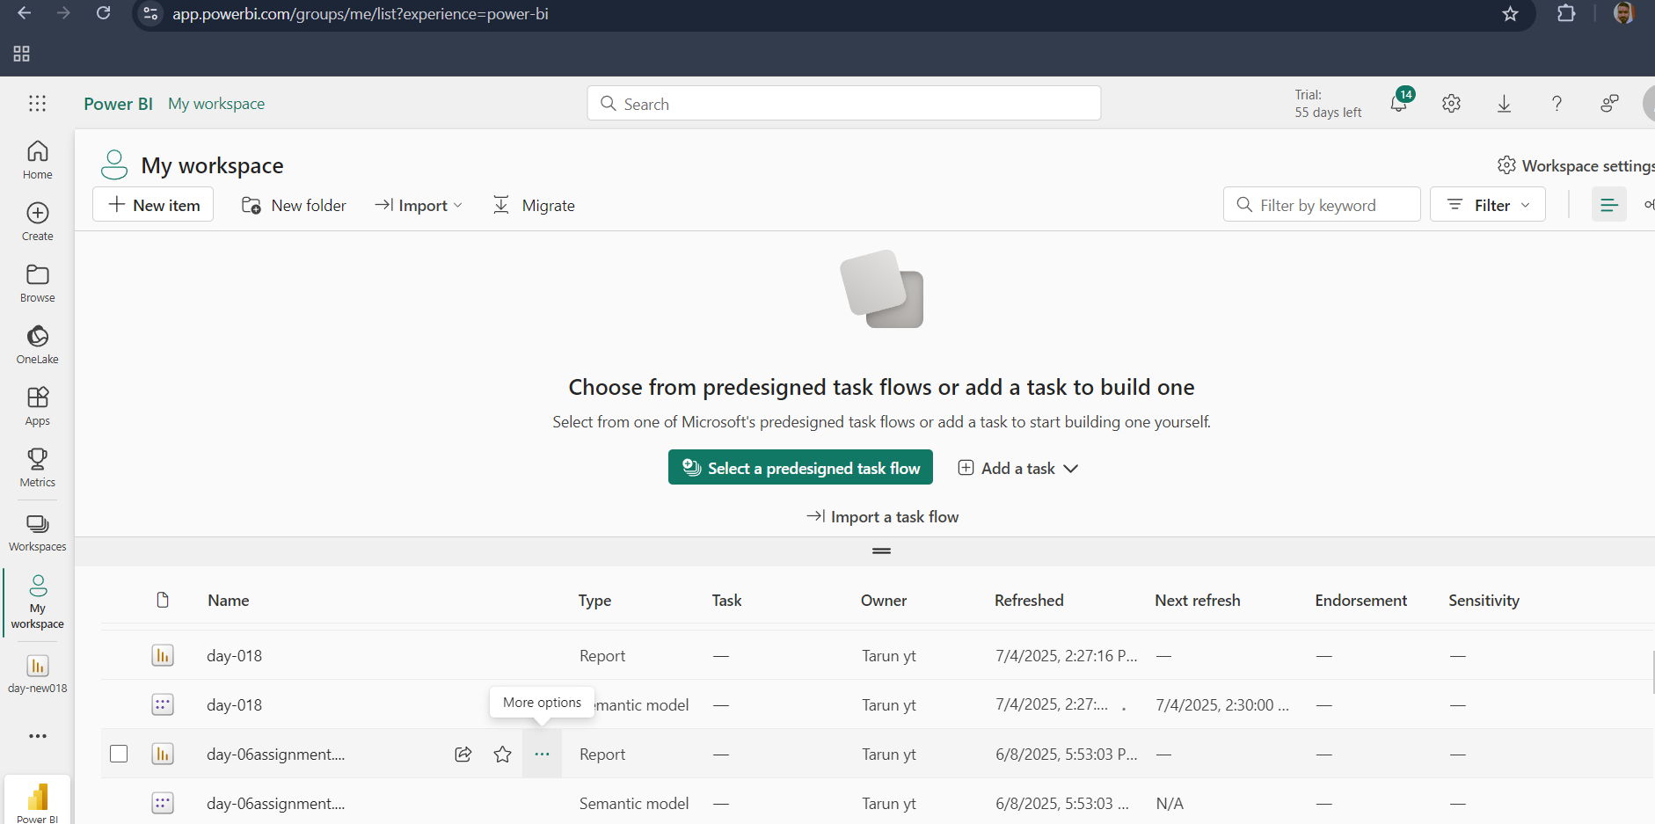

#### 3.2 Connect the Dataset to Gateway

**Step 1:** Go to **Settings > Dataset > Gateway Connection**.

**Step 2:** Ensure **HR_Gateway** appears and is selected.

**Step 3:** Check that the Excel file path is listed and mapped correctly.

*Reference image:* > Gateway Mapping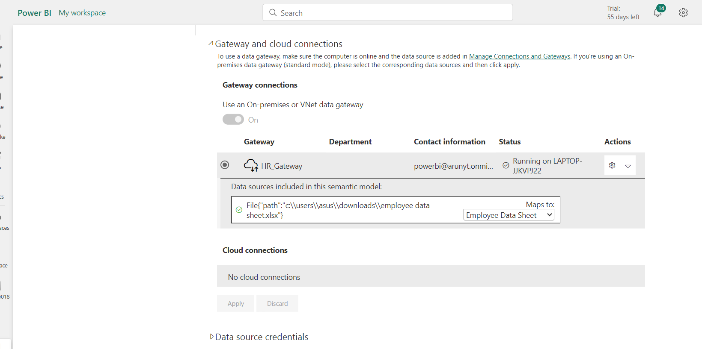

#### 3.3 Configure the Refresh Schedule

**Step 1:** Scroll to the **Refresh section**.

**Step 2:** Turn the toggle ON for **Scheduled Refresh**.

**Step 3:** Choose: - Frequency: **Daily** - Time: **9:00 AM**

**Step 4:** Save the configuration.

*Reference screenshot:* > Schedule Refresh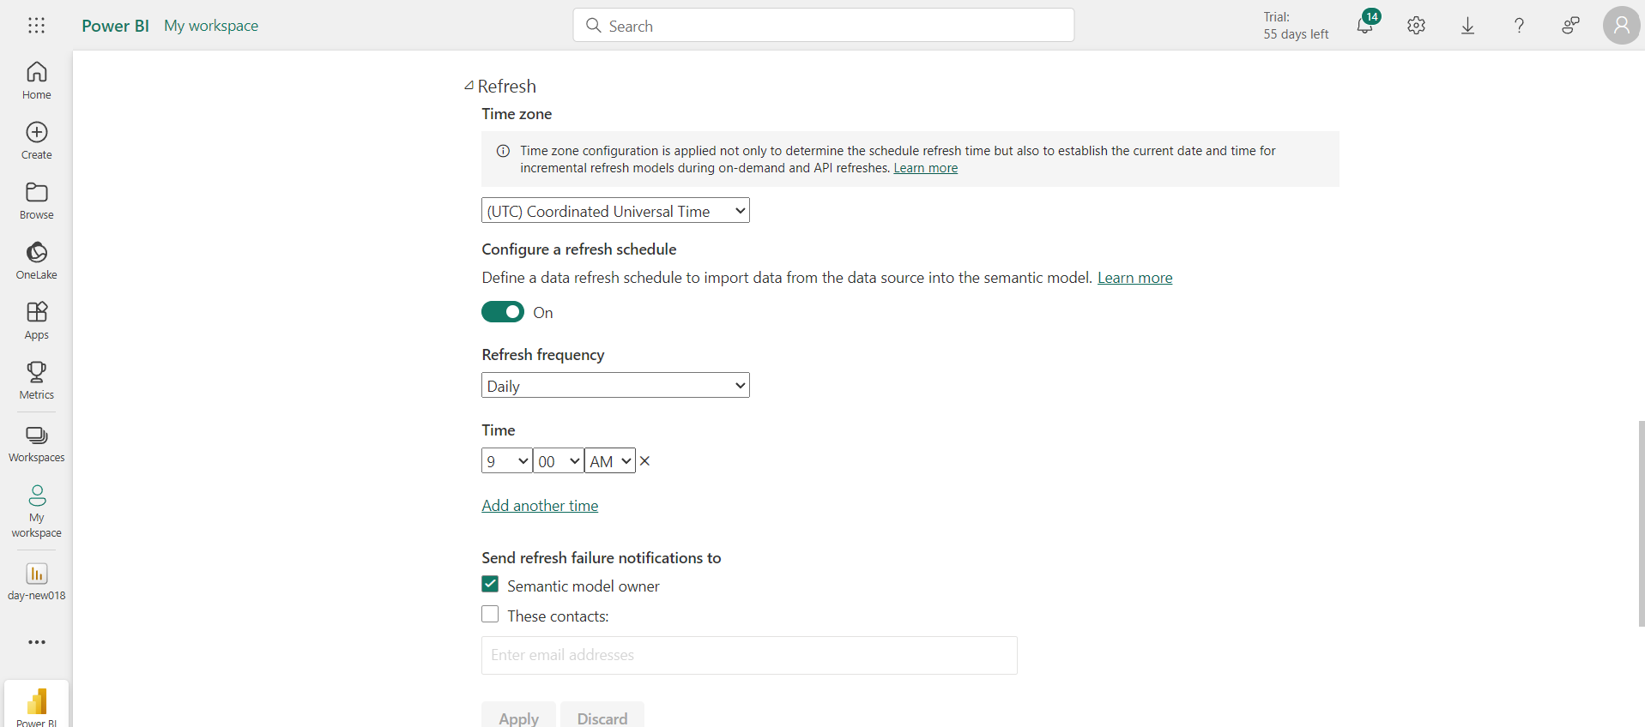

#### 3.4 Manage Gateway Connections

**Step 1:** Navigate to **Manage Connections and Gateways**.

**Step 2:** Locate the file (e.g., Employee Data Sheet.xlsx) and verify connection name, file path, and authentication method (Windows).

*Screenshot below:* > Manage Connections

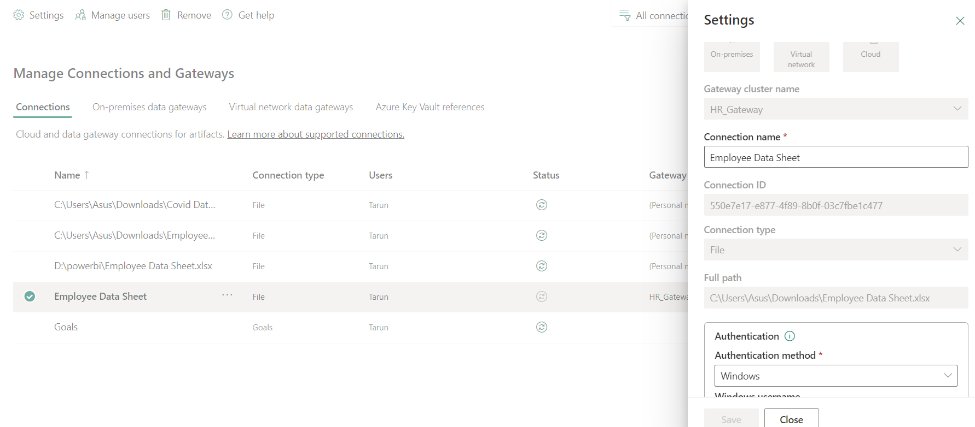

**✅ Task Completed Successfully**

1. Installed and configured the data gateway.

2. Updated the Excel data.

3. Scheduled automatic refresh of the employee report through the gateway.